Use case-7

Technical Stack

1. Lambda functions
2. API Gateway
3. IAM roles
4. Docker for application containerization
5. ECR
6. CloudWatch for logs and metrics
7. S3 for terraform state locking

Application Architecture:

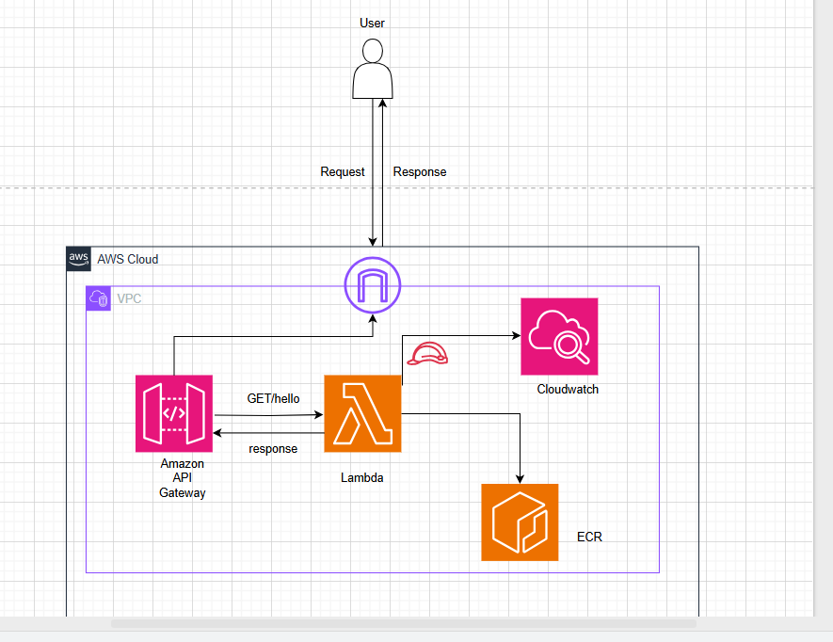  
  
After implementing the terraform code, I can able to launch my required infrastructure.  
  
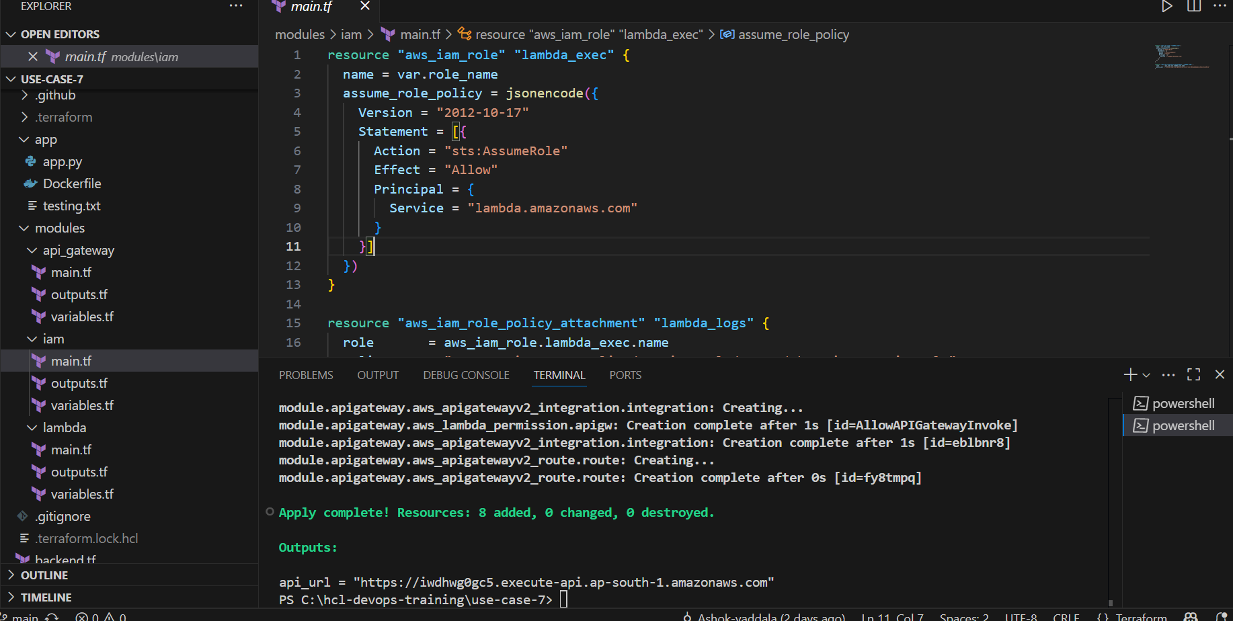

Also the required infrastructure has been created in the AWS cloud provider.  
  
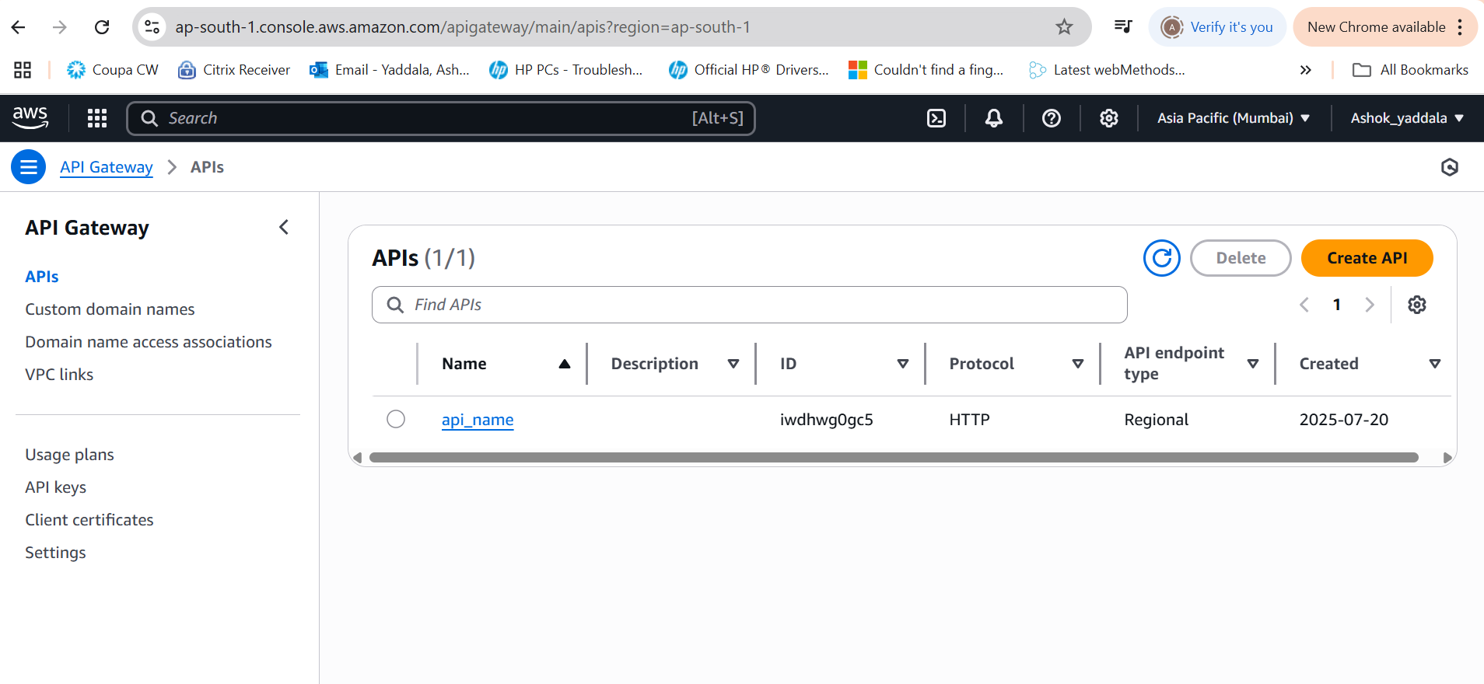

After accessing API Gateway end point url, I can able to access my application.

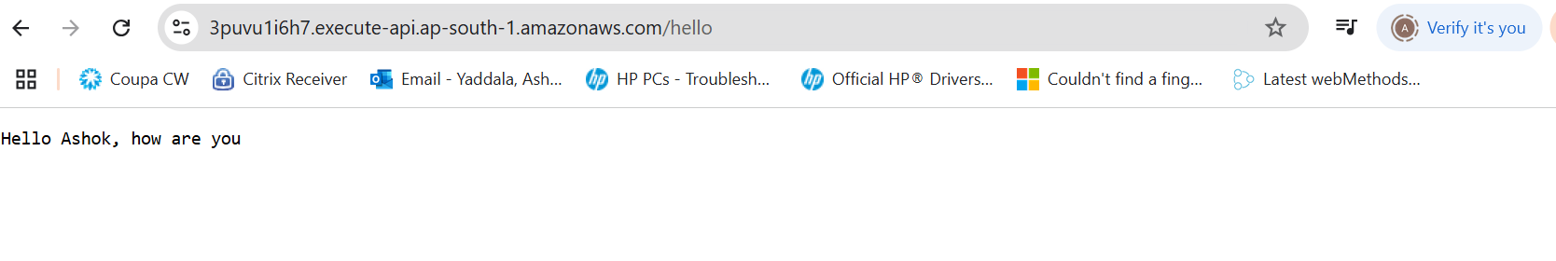

Implementing the CI CD by using Git hub actions.

By using below github actions pipeline am creating ECR repo and pushing my application image to ECR repo. So from my application am consuming this image.

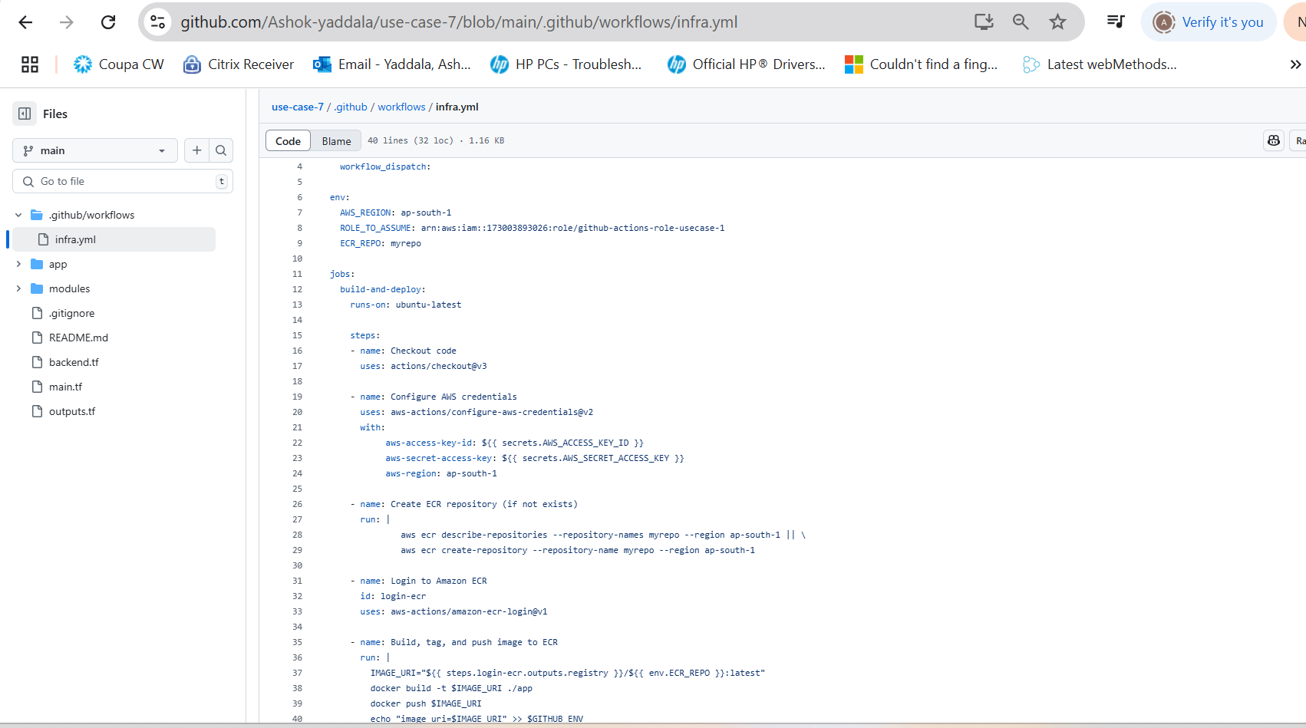  
  
Below is the main pipeline implementation for the current application.

